
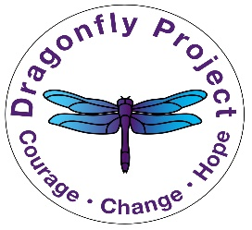

The Cycle of Abuse

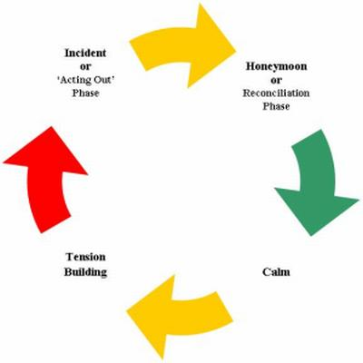
The domestic violence cycle of abuse diagram helps us to understand the different phases which typically occur in abusive relationships before, during and after an abusive episode.
Most abusive relationships display a distinct pattern, known as the Cycle of Abuse or Violence. Abuse is rarely constant but alternates between: tension building, acting out, the honeymoon period and calm.
Not all relationships follow the same cycle, and individual experiences vary, some stages - especially the honeymoon or calm periods, may shorten or be left out completely, especially as the abuse intensifies over a period of time.
Each stage of the cycle can last from a few minutes to a number of months, but within an abusive relationship, the following stages can often be pin-pointed:

TENSION BUILDING -
- Tension starts and steadily builds
- Abuser starts to get angry
- Communication breaks down
- Victim feels the need to concede to the abuser
- Tension becomes too much
- Victim feels uneasy and a need to watch every move

INCIDENT or "Acting Out" phase
- Any type of abuse occurs
- Physical
- Sexual
- Emotional
- Or other forms of abuse as found in the power and control wheel.

HONEYMOON or Reconciliation phase
- Abuser apologizes for abuse, some beg forgiveness or show sorrows
- Abuser may promise it will never happen again
- Blames victim for provoking the abuse or denies abuse occurred
- Minimizing, denying or claiming the abuse wasn't as bad as victim claims

CALM before the tension starts again.
- Abuses slow or stop
- Abuser acts like the abuse never happened
- Promises made during honeymoon stage may be met
- Abuser may give gifts to victim
- Victim believes or wants to believe the abuse is over or the abuser will change
(Often the cycle of violence is portrayed as 3 steps: tension, acting out and honeymoon phases, where the Honeymoon and Calm phase are seen as one.)

