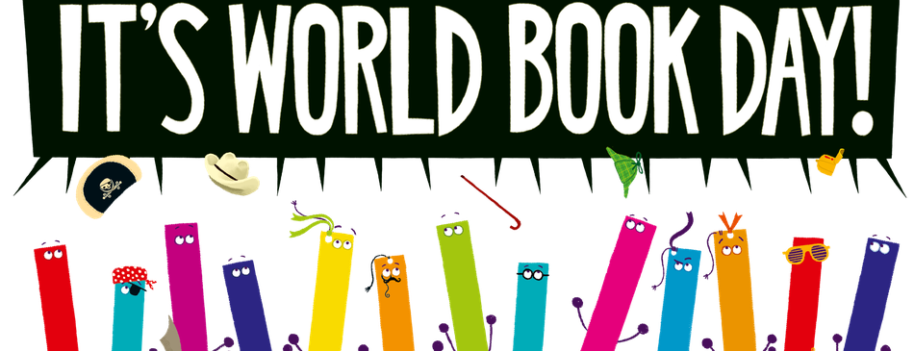

Dear Year 3,

Today is World Book Day and we are going to spend the day celebrating reading and stories that we love.

For your learning today, I would like you to complete at least three activities from the grid below (one of them should be the reading choice). Please share pictures of your learning with me on Dojo. Mrs S. has also been sharing challenges throughout the week too which you can work on today.
Search through your books to try and complete the world book day scavenger hunt. (sheet on dojo) | Paint a pebble with a design inspired by one of your favourite stories. You could paint several pebbles as different characters from a story if you want to! | Bake something inspired by a book or a story. I’ve always fancied baking Bruce Bogtrotter’s chocolate fudge cake from Matilda.
Arrange some of your favourite books together and take a ‘shelfie’! | Write a book review of the most recent book you have read. (There is a template on class dojo.) | Design a new cover for your favourite book.
Watch one of the World Book day live sessions  https://www.worldbookday.com/online-masterclasses/interactive-picture-books/ | Just read!  Pick a great book or magazine and just enjoy reading. | Write a quiz about your favourite book and then test someone in your family.

