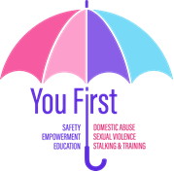


POWER and CONTROL
Abusers believe they have a right to control their partners in the abusive relationships by utilizing the tactics found in the power and control wheel, by:
- Telling them what to do and expecting obedience
- Using force to maintain power and control over partners
- Feeling their partners have no right to challenge their desire for power and control
- Feeling justified making the victim comply
- Blaming the abuse on the partner and not accepting responsibility for wrongful acts.
The characteristics shown in the power and control wheel are examples of how this power and control are demonstrated and enacted against the victim.
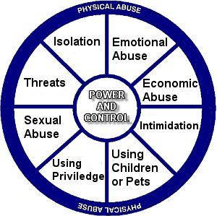

Isolation
- limiting outside involvement
- making another avoid people/friends/family by deliberately embarrassing or humiliating them in front of others
- expecting another to report every move and activity
- restricting use of the car
- moving residences

Emotional and Mental Abuse
- putting another down/name-calling
- ignoring or discounting activities and accomplishments
- withholding approval or affection
- making another feel as if they are crazy in public or through private humiliation
- unreasonable jealousy and suspicion
- playing mind games

Economic and Financial Abuse
- preventing another from getting or keeping a job
- withholding funds
- spending family income without consent and/or making the partner struggle to pay bills
- not letting someone know of or have access to family/personal income
- forcing someone to ask for basic necessities

Intimidation
- driving recklessly to make another feel threatened or endangered
- destroying property or cherished possessions
- making another afraid by using looks/actions/gestures
- throwing objects as an expression of anger to make another feel threatened
- displaying weapons

Using Children or Pets
- threatening to take the children away
- making the partner feel guilty about the children
- abusing children or pets to punish the partner
- using the children to relay messages

Using Privileges (perceived or cultural)
- treating another like a servant
- making all the big decisions
- being the one to define male and female roles
- acting like the master or queen of the castle

Sexual Abuse
- sex on demand or sexual withholding
- physical assaults during sexual intercourse
- spousal rapes or non-consensual sex
- sexually degrading language
- denying reproductive freedom

Threats
- threats of violence against significant third parties
- threats to commit physical or sexual harm
- threats to commit property destruction
- threats to commit suicide or murder

Physical Abuse
- biting/scratching
- slapping/punching
- kicking/stomping
- throwing objects at another
- locking another in a closet or utilizing other confinement
- sleep interference and/or deliberately exhausting the partner with unreasonable demands and lack of rest
- deprivation of heat or food
- shoving another down steps or into objects
- assaults with weapons such as knives/guns/other objects

