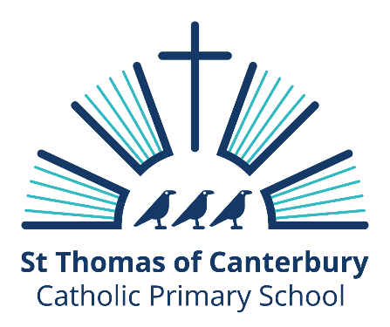

Strategic Plan 2021-2025

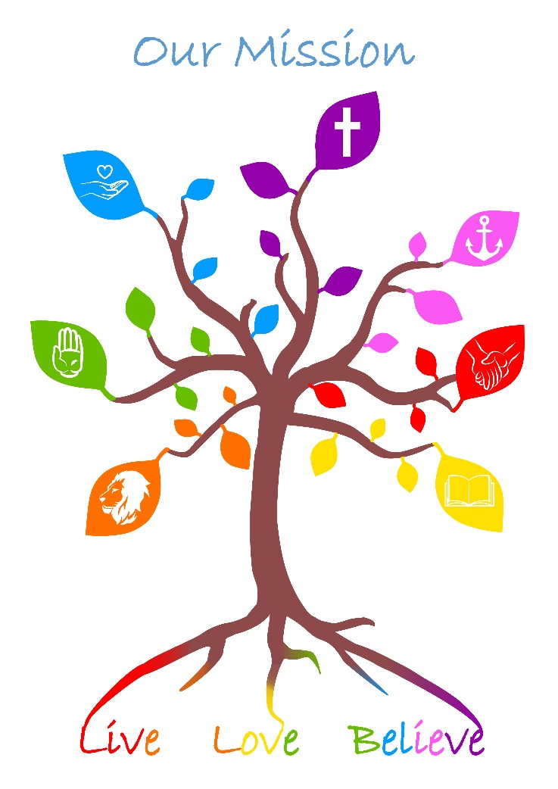

Introduction
The Leadership at St Thomas of Canterbury and the School community have identified what our vision for the children is in the next four years. This Vision was explored with children, staff, parents and governors so that it represents the vision for our whole community.

We are proud of our school and look to this vision as a way to share what our aspirations are for the next few years. The ways in which we will achieve this vision will be shared yearly in the School Improvement plan (SIP) which is also published on the website.

Our Mission: Live, Love, Believe, is the web upon which all our school life is woven.
Our Vision: Aspirational in Life, Joy in Love and Transformed in Belief, are the threads that strengthen this Mission so that it is impactful for all who are part of school community.

Aspirational in Life
This means that the school offers children a vibrant and challenging curriculum that supports the educational growth for each child, meeting them where they are and given the confidence and skills to aim high. Our learning teams and school leadership show through their actions that our school is a school that is the best for all its pupils.

Joy in Love
This means that all children have the experienced of professional love within the school, recognising that each child is their parent’s child, their community’s child, the world’s child and God’s child. Each child should have the opportunity to grow emotionally strong in our school, that recognises that each child has different life experiences that impact their arrival with us.
Transformed in Belief
This means that all children have the opportunity to develop as their personal spiritual life. This is shared within the school through the Catholic teachings of Love of God and Love of neighbour and the Virtues that underpin the school Mission.

Our vision ensures that the school’s improvement plans as well as the curriculum and experiences within the day to day life of the school are focussed to ensure that ALL pupils will achieve the very best that they can, knowing that they are loved by God.

Plan Development and Review
The strategic plan is an ongoing five-year long-term strategic intent. In setting out our strategic priorities we share with and build with our community the aims of all the actions within the school.
The plan was developed with all stakeholders in our community so that this is seen as a vision shared by all for all.
The plan will be reviewed with all stakeholders annually.

Each year the Headteacher reviews a Self-evaluation form with the Governing Body:
2021: St Thomas of Canterbury is a one form entry Voluntary Aided Catholic primary school. The school is situated in the village of Carisbrooke, with views of the Castle in the grounds of the school, which have grown recently with the gift of wooded areas at the rear of the school. The outside environment has through recent improvements become used more frequently and effectively through Forest Schools and other outside learning.
The school was judged as Good by Ofsted (2018) and by the Diocese (2017). The staff have worked to maintain and strengthen the school from these points of contact, being aspirational for its pupils. The areas in which the school needed to improve were:
Improve the quality of teaching and the progress that pupils make by:
– ensuring that teachers’ expectations of what pupils can achieve are consistently high and tasks challenge pupils more effectively
– making sure that questions challenge pupils to think more deeply about their learning
– providing pupils with more opportunities to use and apply their writing skills and knowledge, particularly when writing at greater length.
There is a strong focus in engaging with the families to increase the support for the children in their learning goals. This has been seen as a position of strength by the families who send siblings to the school and who recommend the school to others. This is reflected in the increased numbers within the school which are presently at 195 with some classes now also holding a waiting list.
We have an experienced staff cohort who engage with the self-evaluation process and reflect on their own practise and ways to grow within their own practice.
As a Catholic School, the Mission and Virtues are the web and the threads of the school's purpose and aims. The school operates closely within the Federation of St Mary's and St Thomas's. Strong links are forged and maintained with the Island Catholic Cluster as well as the Diocese and Catholic Teaching School Alliance. The Head has also joined the National Formation of Catholic Leaders Alliance.
Covid impacted the 2019-2020 summer term and continues to affect the 2020-2021 academic year. The school works in a COVID safe manner and continues to monitor and respond to guidance issued by Public Health England and the Department for Education.

Strategic priorities
Aspirational in Life
St Thomas’ believes that the stronger the start the children achieve within their formative years within the school the stronger their growth throughout the school. We have committed to this belief by enabling additional staff to support the first two years of the school. The focus within EYFS is to enable pupils to quickly engage with the learning environment so that more pupils are able to access the Early Learning Goals by the end of their time in Reception. This means when they join Year 1 they do so in as strong a way as possible. There is a clear focus on language and phonic acquisition with the school using Read Write Inc Phonics to underpin this learning.

St Thomas’ curriculum is planned to be thorough and show clear progression of knowledge understanding and skills. Subject leaders support this within the class by reviewing the planning and delivery of the subject within classrooms and supporting through cpd and resource suggestions
Our outdoor curriculum following the acquisition of woodland at the rear of the school is a priority so that children are ale to use this resource to engage first hand with their curriculum as well as explore as stewards of God’s creation.
Each pupil with the support of the learning teams, the subject leads, the SENDco and the Leadership will be focussed on understanding in a granular way the needs of the pupils so that we can address barriers and meet the needs of the pupils. This will be supported within school by a review of the SEND provision and the use of Balance to planning assess and track progress of pupils.

Joy in Love
To be positive learners, the pupils need to have good mental wellbeing. They need to have the opportunities to love and respect themselves to be able to love and respect others as well as the opportunities to experience the love of God.
Pupils will be supported through the school establishing the Acorn project which will enable to the school to be fluent in the attachment and trauma needs of all pupils and have strategies and responses planned so that the pupils are able to progress in their well-being so that they are more open to their learning. This builds on and encompasses the work already established through the ATAS training and the Zones of Regulation. The outcome will be a whole school model of supporting the range of attachment and trauma needs within the school. This will be monitored through an attachment provision map and pupil acorn passports that will progress with each child throughout their time at the school.

Transformed in Belief
As a Catholic Community the school will be an outward sign of the inward grace afforded to us by God’s love. This will be evident in the opportunities developed for each child to engage annually with a programme of faith that develops links with the parish, school community and Diocese. As well as the stewardship experienced within the curriculum, our children will also have the opportunities to see themselves as part of the world community through trips, visitors and activities. The COVID lockdown has meant that many children have had their horizons become more and more limited. This focus will be planned to reopen and indeed broaden the horizons again for the whole community.

How will we know we have been successful in our strategic priorities?
Our pupils will leave St Thomas’ as role models for others. They will grow onwards to become the leaders of the future.
They will believe in themselves, be aspirational for themselves and their communities.
They will embody the statement: be the change you want to see in the world.

Their lives will continue to live the mission of the school and the vison of Pope Francis when he spoke to children saying:
“Learn from wonder; nurture astonishment. Live, love, believe.”

